S3 bucket ( Simple Storage Service)

Contents :
- What is S3 buckets and what are its features ?
- Create 2 buckets , one in singapur region and another one is north region . check if you can access other bucket. (to check global level accesss)
- Create 2 bucket devxxx and testxxx . Now upload a hi.txt and bye.txt inside - devxxx/data/.
- After that copy hi.txt file into testxxx
- Move bye.txt file into testxxx
- Implement Bucket Versioning in devxxx .

- What is S3 buckets and what are its features ?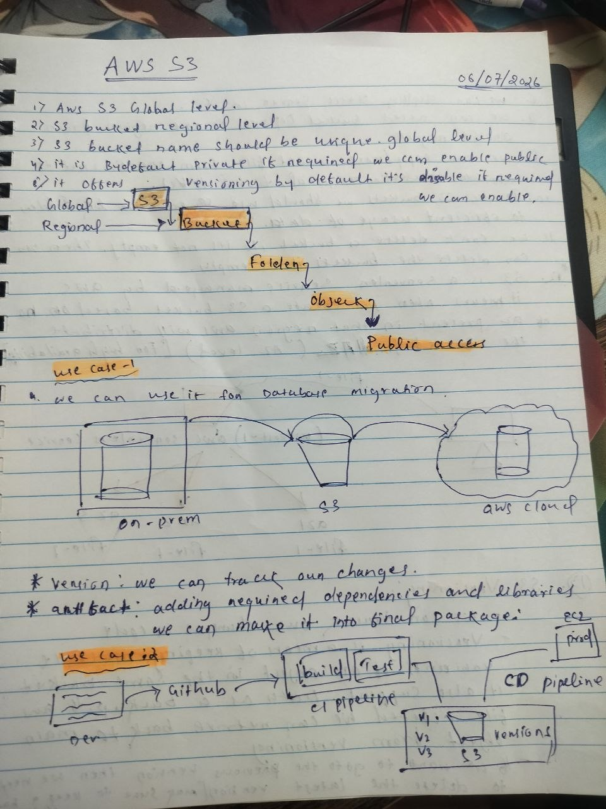
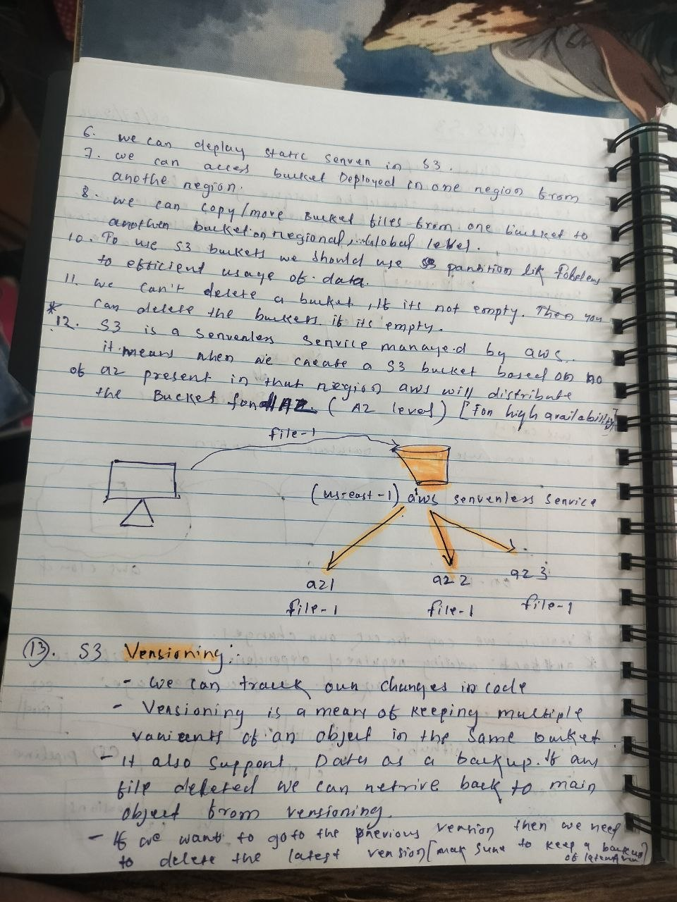
- Create 1 bucket(s3-singapur ) in singapur region. check if you can access other bucket upload some files and switch to other region ie North Verginia to check if you can see the bucket in that region . if are able to see means S3 is global level. (to check global level accesss).

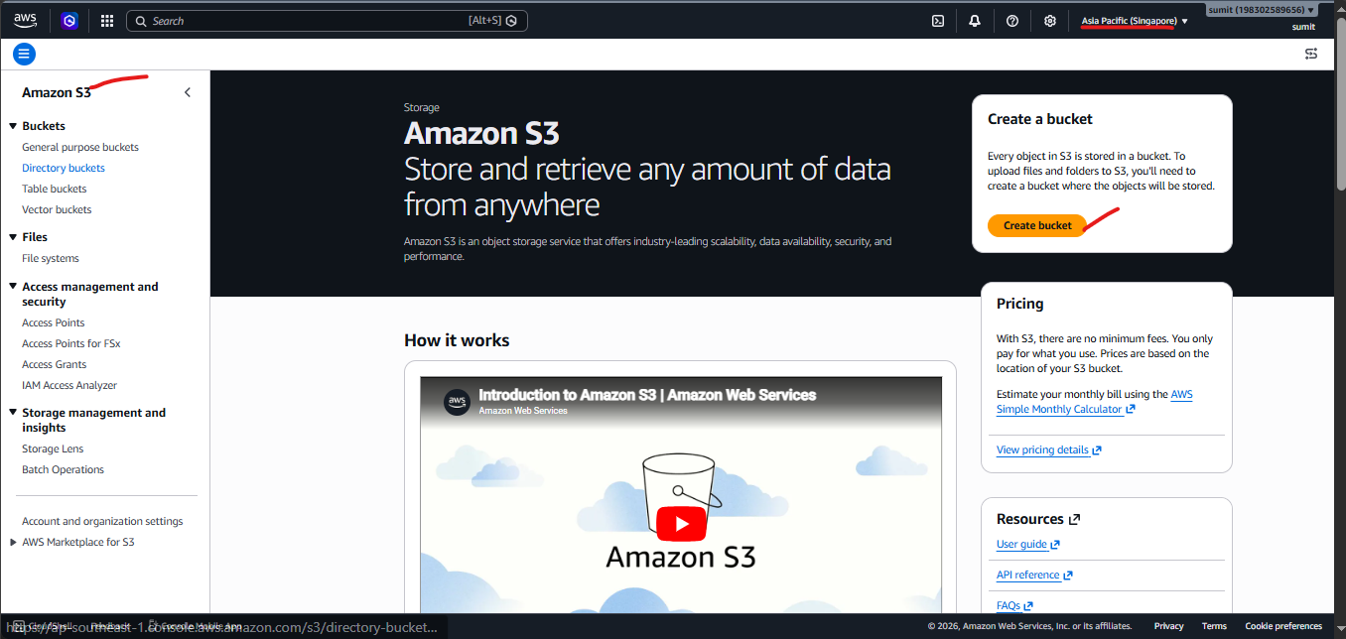
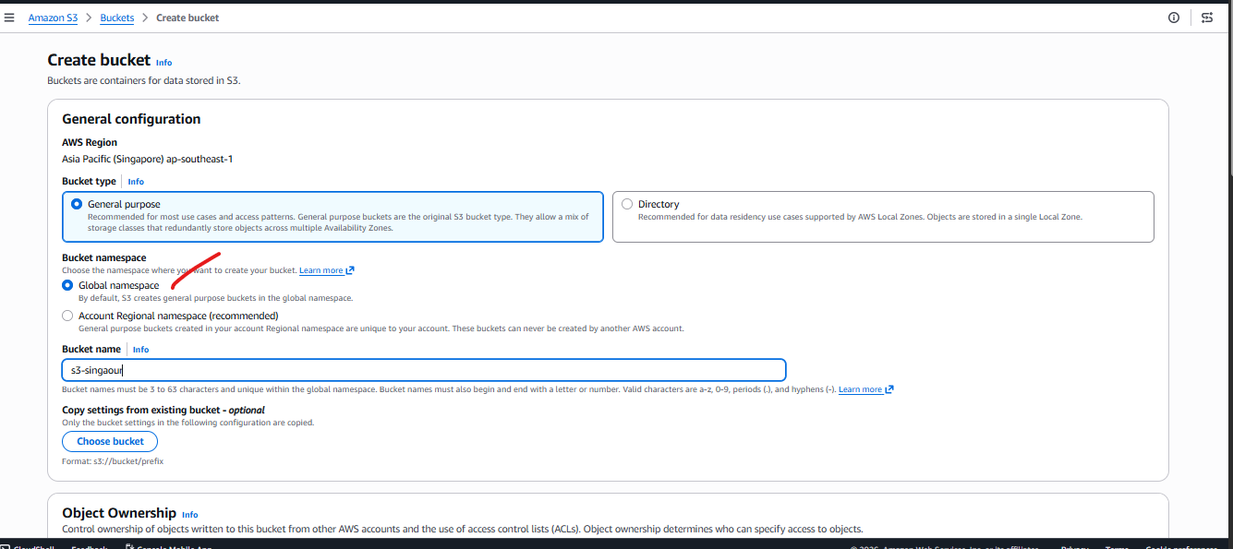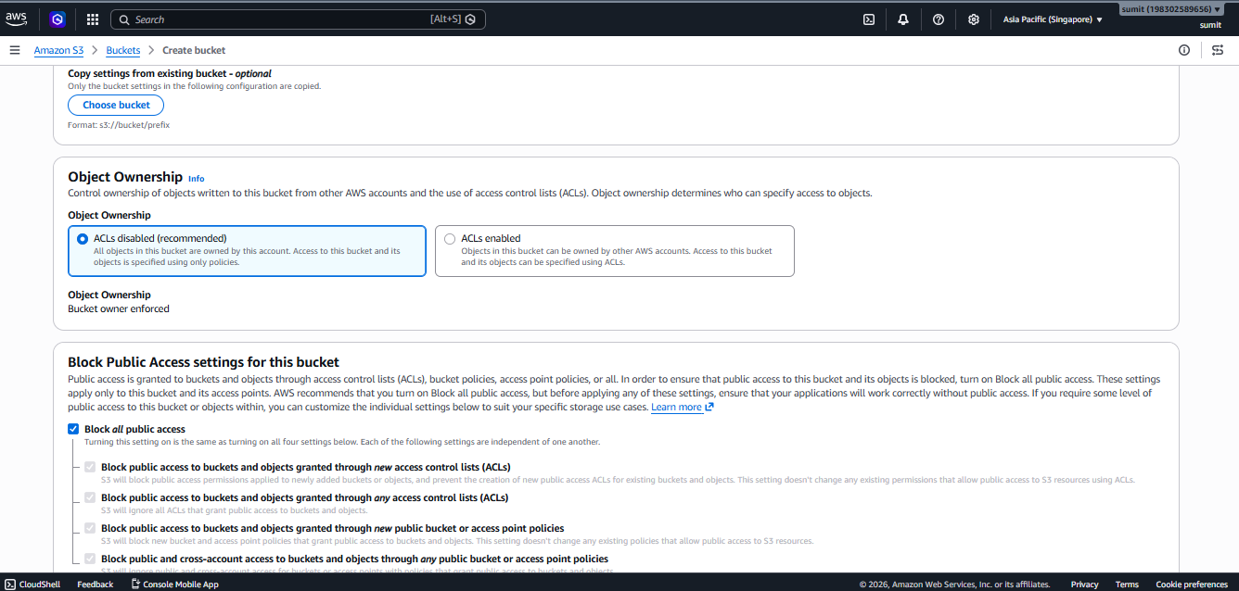
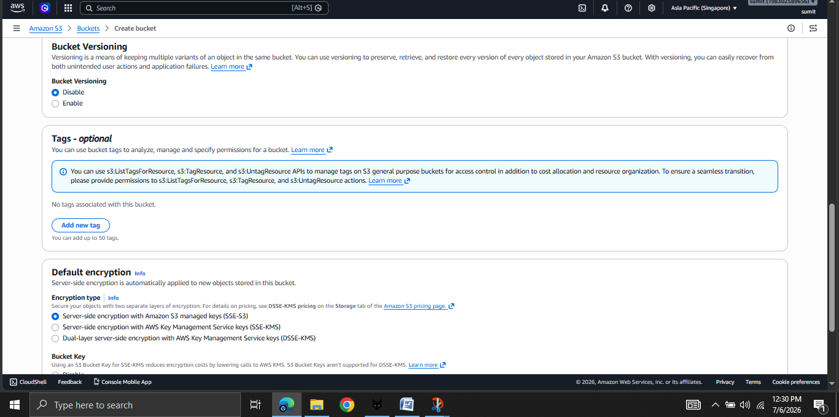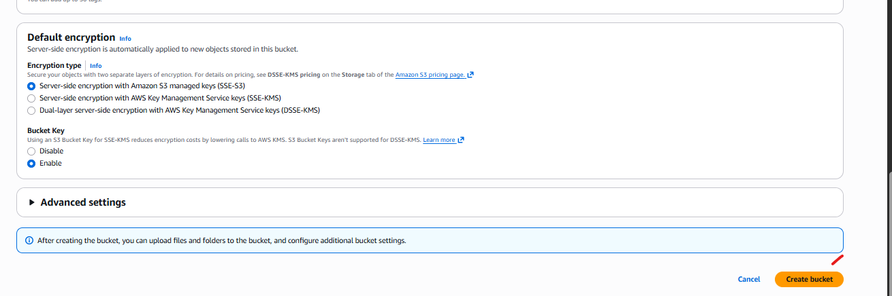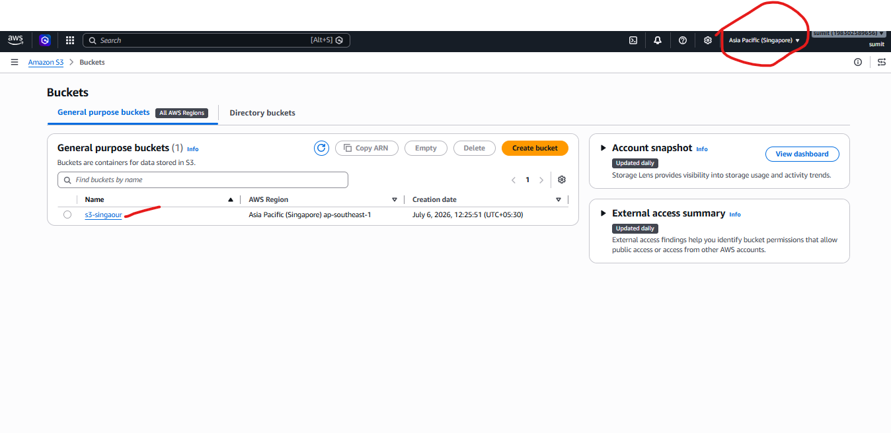
Now Switch to north Verginia to check if you can able to access the bucket.
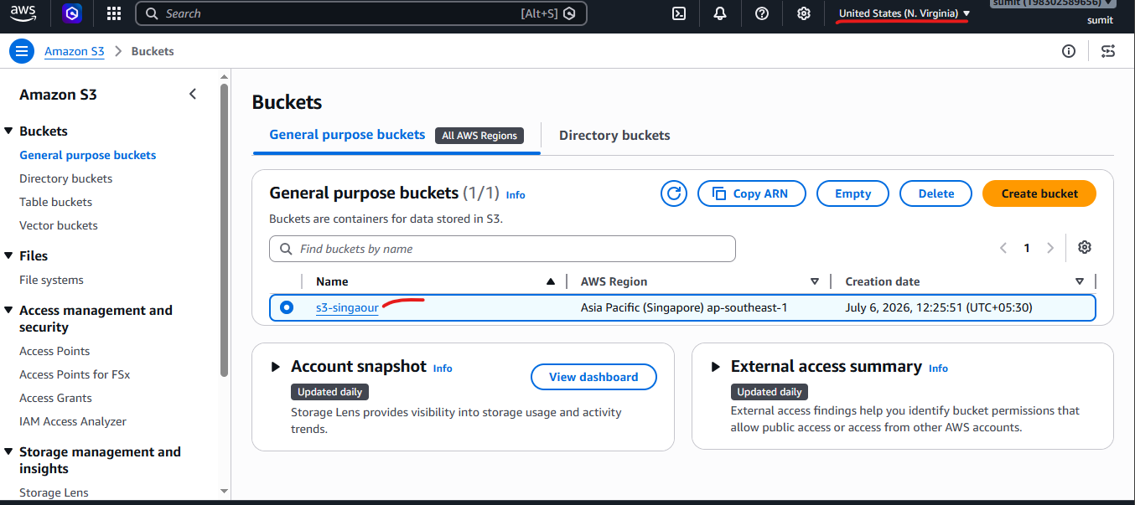

- Create 2 bucket devxxx and testxxx inside s3-singapore S3 service. Now upload a hi.txt and bye.txt inside - devxxx/data/.
- After that copy hi.txt file into testxxx
- Move bye.txt file into testxxx
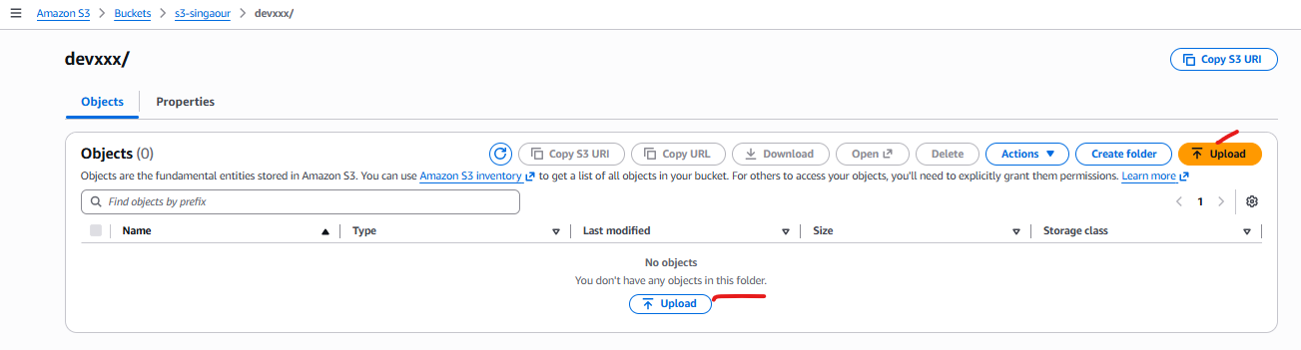
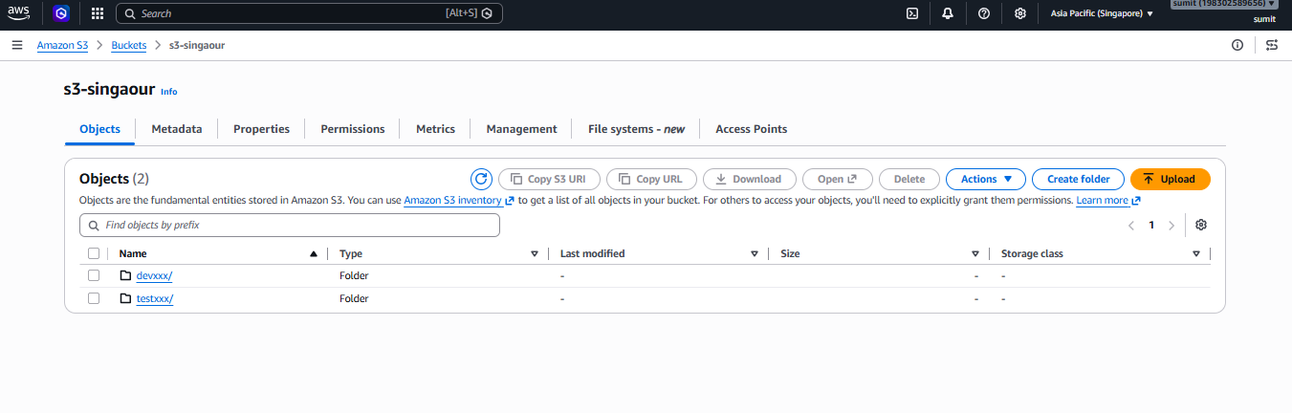
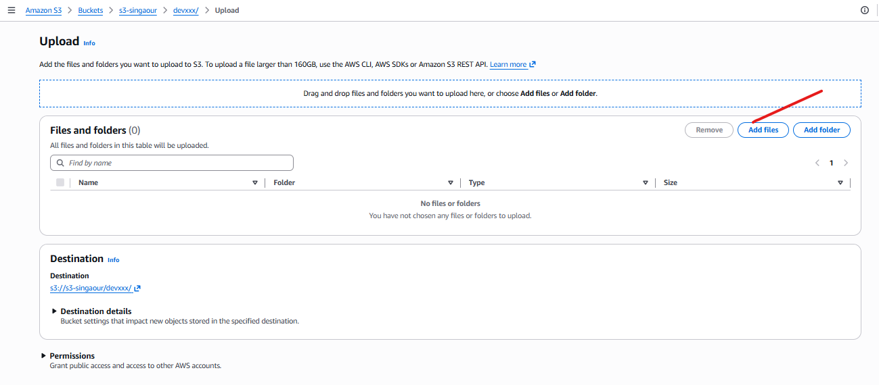
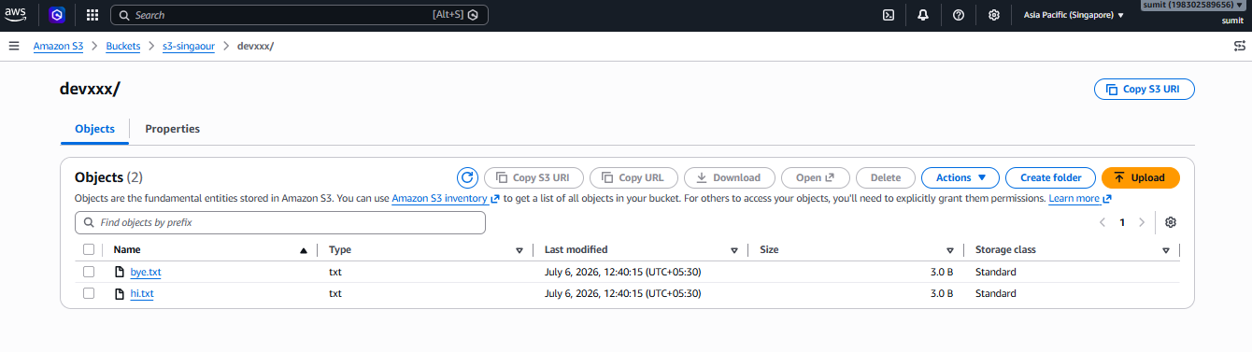

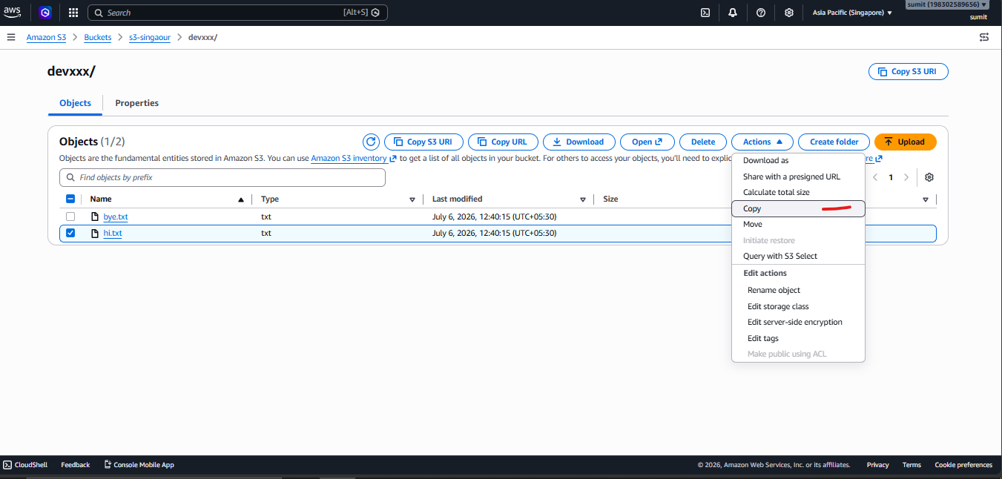
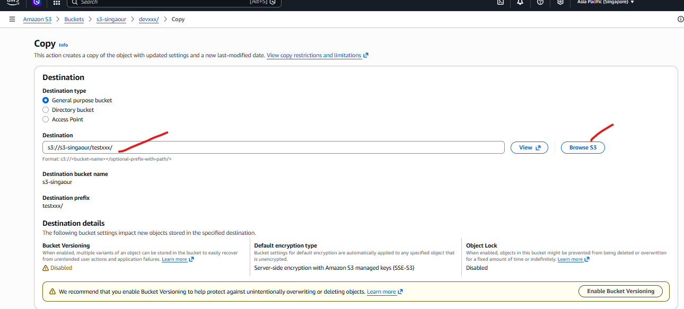

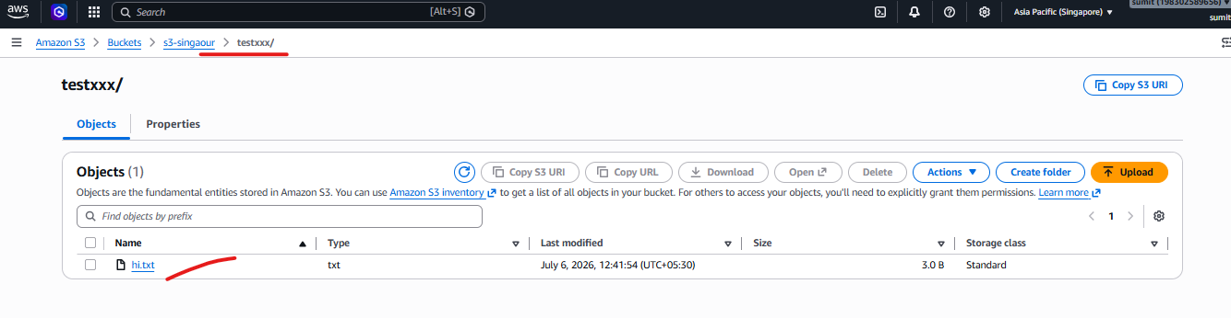
Do the same steps for Move bye.txt

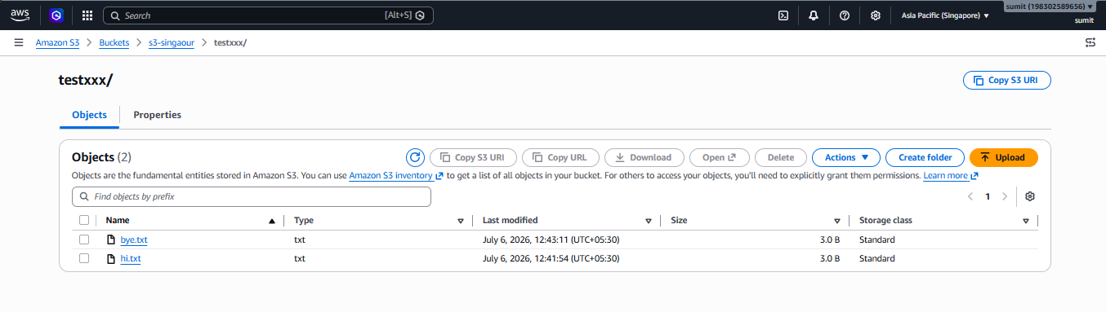

- Implement Bucket Versioning in devxxx .
- Enable bucket versioning in devxxx
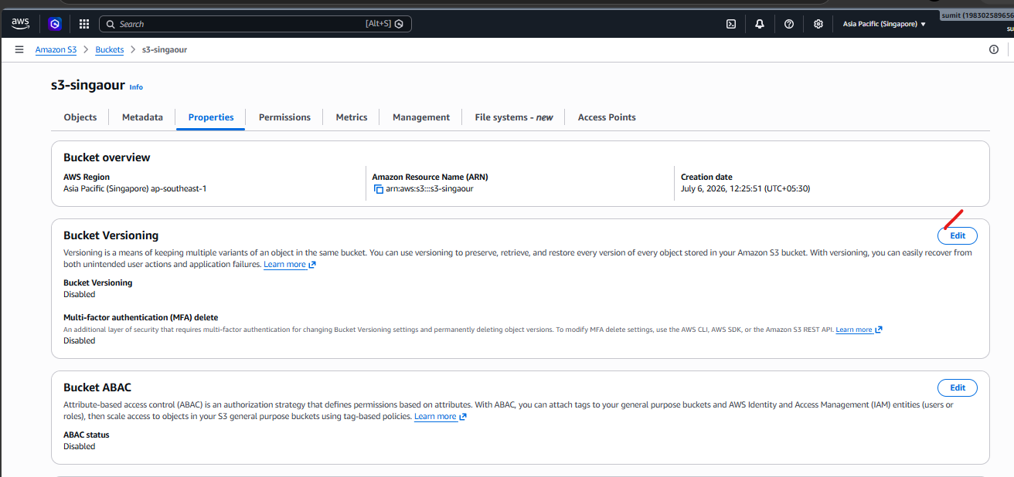

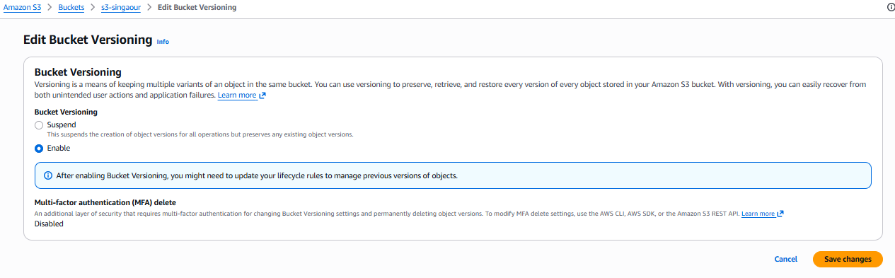
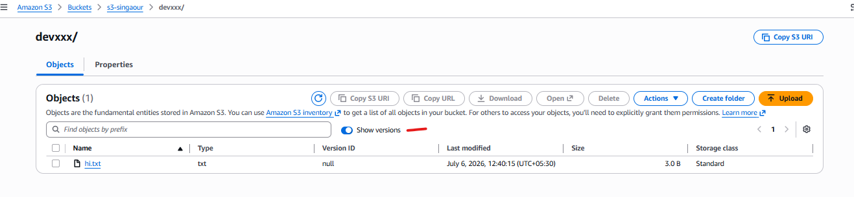

Select the hi.txt . Do some changes in hi.txt in locally and again upload it . and enable the show versions options .

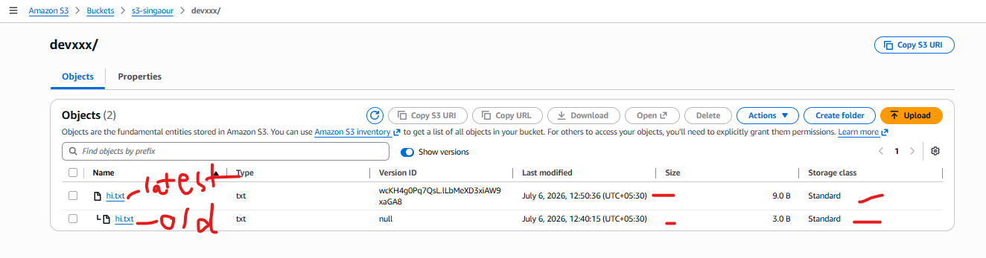

You can go back to the provious verisions by deleting the latest version .
